**Setup:**

Step 1: Install Python and required packages

Go to <https://www.python.org/downloads/> and hit download. All development was in Python 3.7, so you may choose to download the latest Python 3.7 version instead of the latest Python version.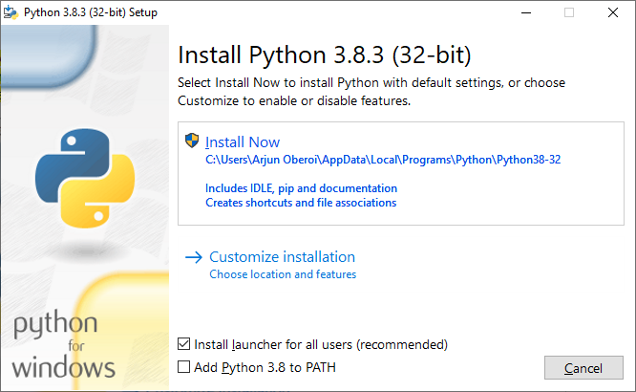

Click the checkbox “Add Python 3.X to PATH” which will make it much easier to install the required additional Python packages. Then hit “Install Now”. Make sure Python is installed for all users.

Open command prompt as an administrator, and navigate to the folder containing this file, using the cd command. There will be a text file called requirements.txt in this folder. requirements.txt is a list of Python modules required as well as the versions I tested them at.

Run the command “pip install -r requirements.txt” which reads requirements.txt and installs the modules listed.

Step 2: Launch the Input Interface GUI

We’re going to run the .py file which is the whole program. I will show one method of running it.

Open Windows Explorer and navigate to the folder with this file in it. You should see a file called “input_interface_gui.py”. Double click it to run the file. If it asks you what program you want to run it with, you’ll need to scroll down and click “Look for another app on this PC”, which should open up a Windows Explorer window.

Navigate to the folder python installed. In my case it’s C:\Program Files\Python37. Select python.exe, and it should run.

If it’s crashing, this method doesn’t show the errors very easily. For debugging and code editing, I use IDLE, which was installed when you installed python. You should be able to open IDLE by clicking the windows key and typing in “IDLE”. Open the input_interface_gui.py file in IDLE, and hit F5 to run the program.

To verify that it works initially, run the program without plugging in the Input Interface to the computer or other serial devices.

Getting custom skins:

The Input Interface GUI is compatible with SNES NintendoSpy/RetroSpy Skins. Put any skins in the “skins” folder. I’ve included a few skins from Proximity Sound (<https://proximitysound.com/skins/snes/>), as well as a DS Lite Skin which doesn’t look as nice, but still works. It currently isn’t compatible with the hotkey function of the skins, that may be added in a future update.

Program Usage:

Upon startup of the program, you’ll see a window that looks like this:

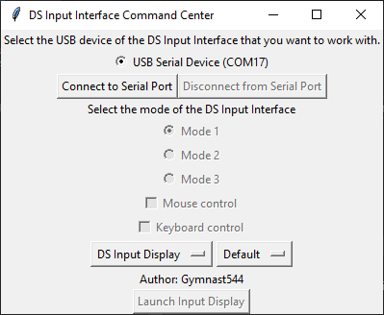

Select the serial device that you want to connect to and hit the “Connect to Serial Port” button. There’s a function in the code which automatically filters to include only DS Input Interface devices using a custom protocol, so it shouldn’t show extra devices.

Mode 1 is the default mode for the DS Input Interface. This mode works with the built-in input display as well as allows the user to control the DS using the mouse, keyboard, or an external controller. To launch the input display, select the skin that you would like to use, and then hit the “Launch Input Display” button. You can enable mouse and keyboard control once the input display is running.

In order to use an external controller, you’ll need to use a program to convert your controller inputs to keypresses. I chose to use this method as it allows the program to support many more controllers than just the ones that I own. I’ve found that AntiMicro works well. Only boot up AntiMicro after you have connected to the Input Interface’s serial port, as I’ve found AntiMicro tries to connect to the Input Interface, which makes the Input Interface not work.

This looks like a good guide to installing and using AntiMicro <https://www.instructables.com/id/PC-Game-Controller-Mapping/>

The keyboard input is:

"a":"a", "b":"b", "x":"x", "y":"y", "left":"left", "right":"right", "up":"up", "down":"down", "l":"l", "r":"r", "ctrl":"start", "right ctrl":"select"

If mouse control is enabled, when you click on a button, it should press the button on the DS.

Mode 2 allows the input interface to emulate a USB keyboard.

Mode 3 allows the input interface to emulate a USB gamepad. This works natively with RetroSpy, and I have a sample skin for this in the Retrospy-skins folder.

The “Skin adapter.py” file makes it easy to convert an SNES RetroSpy skin to one that works with the DS Input Interface with RetroSpy and Vice versa. (The builtin input interface works natively with SNES skins, so this program is only needed if you’re using RetroSpy with the DS Input Interface in Mode 3). Just copy the file into the folder of a skin, and run the program.